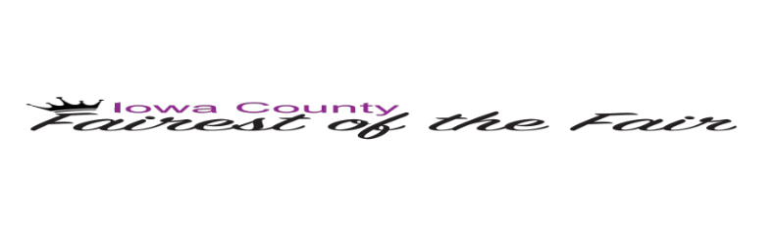

Junior Fairest of the Fair

JOB DESCRIPTION
o Represent Iowa County Fair Society at County Fair, parades & other functions for one year
o Assist the Fairest of the Fair at the Iowa County Fair, September 3 – September 7
o Applicant need to have a strong appreciation for the fair but is not required to have shown at the fair.

WHO IS ELIGIBLE TO PARTICIPATE IN THE SELECTION PROCESS?
o Applicant must be between 11-14 years of age.
o Position open to young people who have been residents of Iowa County for at least one year prior to entry.
o Applicant may be an entrant in only one county/district fair which they consider their “home” fair. An applicant must reside in the county they represent. Only exception: They may reside in an adjoining county if the majority of their activities are in the county where they enter.

Name _____________________________________ Age _____Date of Birth______________ Address____________________________________City___________________Zip__________Phone ________________________ Parent/Guardian’s Name______________________
Name of School Attending: ____________________________Grade______________________

Goals and Hobbies: _____________________________________________________________ ______________________________________________________________________________ _____________________________________________________________________________

School Clubs & Organizations: ______________________________________________________________________________ ________________________________________________________________________________________________________________________________________________________________________________________________________________________________________________________________________________________________________________________

School Honors & Awards: _________________________________________________________________________________________________________________________________________________________________________________________________________________________________________________________________________________________________________________________________________________________________________________

Iowa County Involvement (Including 4-H involvement):
____________________________________________________________________________________________________________________________________________________________________________________________________________________________________________________________________________________________________________________________________________________________________________________________________________________________________________________________________________________

Community or Church Activities: ____________________________________________________________________________________________________________________________________________________________________________________________________________________________________________________________________________________________________________________________________________________________________________________________________________________________________________________________________________________

Why do you want to be Junior Fairest of the fair for Iowa County?
______________________________________________________________________________ ________________________________________________________________________________________________________________________________________________________________________________________________________________________________________________________________________________________________________________________________________________________________________________________________________________________________________________________________________________________________________________________________________________________________________________________________________________________________________________

Signature of Applicant____________________________________ Date_________

Signature of Parent/Guardian_______________________________ Date_________

Any Questions - PLEASE Contact: Carolyn Butteris - Iowa County Fairest of the Fair Coordinator. Please email the completed form and a recent photograph to: kcbutteris@gmail.com

All applications must be received by April 1st, 2020!

